Experiment 1: Convert an Image to Grayscale
Software / Tools: Python · OpenCV (cv2)

AIM
To read a color image using Python (OpenCV) and convert it into a grayscale image.
ALGORITHM
1. Import the OpenCV library (cv2).
2. Read the input color image using cv2.imread().
3. Convert the BGR color image to grayscale using cv2.cvtColor() with the flag COLOR_BGR2GRAY.
4. Display / save the original and grayscale images.
5. Wait for a key press and close all windows.
PROGRAM (SOURCE CODE)
import cv2

# Read the image
img = cv2.imread("image.jpg")

# Convert to Grayscale
gray_img = cv2.cvtColor(img, cv2.COLOR_BGR2GRAY)

# Save and display
cv2.imwrite("gray_output.jpg", gray_img)
cv2.imshow("Grayscale Image", gray_img)
cv2.waitKey(0)
cv2.destroyAllWindows()

OUTPUT
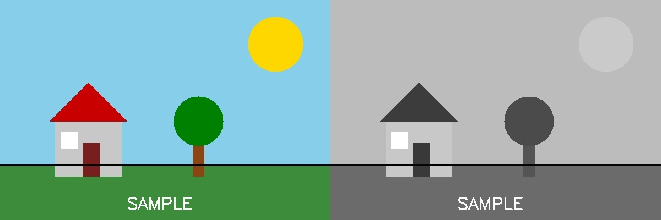
Fig. 1 — Output of Experiment 1: Convert an Image to Grayscale.
RESULT
Read a color image using Python (OpenCV) and convert it into a grayscale image — completed successfully, as demonstrated in the output shown above.

